EVALUATION OF NETWORK RTK PERFORMANCE AND ELEMENTS OF CERTIFICATION – A SOUTHERN ONTARIO CASE STUDY

S. Bisnath, A. Saeidi*, J.-G. Wang and G. Seepersad
Department of Earth and Space Science and Engineering, York University,
Toronto, Ontario, M3J 1P3
* Now at NovAtel Inc., 1120-68th Ave. N.E., Calgary, Alberta, T2E 8S5

ABSTRACT

Over the past decade, network RTK technology has become popular as an efficient method of precise, real-time positioning. Its relatively low-cost and single receiver ease-of-use has allowed it to mostly replace static relative GPS and single baseline RTK for, e.g., cadastral and construction surveys, in urban areas where such networks are economically viable. The Ministry of Transportation of Ontario (MTO) and York University have investigated the performance of commercial network RTK services in Southern Ontario, where performance is defined by a set of developed metrics. It was found that the user horizontal solution had an overall precision of ~2.5 cm (95%), though there were cases of solution biases, drifts and gaps. A follow-on study is developing criteria and pathways for the certification of such commercial network RTK services, focusing on: reference station integration, reference station maintenance, and user solution monitoring. A set of recommendations for network certification is in preparation.

INTRODUCTION

Network RTK (Real-Time Kinematic) refers to GPS and now GNSS (Global Navigation Satellite Systems) technology, where a network of continuously operating reference stations (CORS) provides raw measurements and error corrections to a user’s geodetic-quality GPS / GNSS receiver, allowing for few centimetre-level horizontal positioning in real-time. Such networks are viable in areas with high concentrations of economic activities. In Southern Ontario, network RTK services have been established, maintained and operated by a number of private companies with limited government involvement. Unlike many provincial / state or federal governments in other countries, neither Ontario nor Canada maintains a CORS at a density necessary for network RTK.

This situation and limited existing studies led the Ministry of Transportation of Ontario (MTO) to work with York University in order to evaluate the performance of network RTK in Southern Ontario for use in its surveys MTO and for use by the broader surveying community. This work has been followed by a second partnership to study approaches to certify such commercial network RTK services for government and public use. The results and on-going work from these studies in presented here.

EVALUATION OF NETWORK RTK PERFORMANCE

The overall focus of this study was to investigate the performance of these network RTK services for use in control and engineering surveys by the MTO. This goal was achieved by: evaluating the horizontal performance of these network RTK services, and subsequently recommending procedures for the use of network RTK in MTO control and engineering surveys.

There have been a number of such studies that investigate the performance of network RTK in various locations around the world. An example of a comprehensive static evaluation is Edwards et al. (2008) that evaluates network RTK services in Great Britain. This study focused on the performance of these privately-run networks in terms of solution accuracy and repeatability, improvement with the integration of additional satellite constellations, and performance of the networks at their coverage edges and in presence of significant height differences. The study concluded that, in general, the accuracies (1σ) of network RTK in Great Britain range from 1.0 to 2.0 cm in the horizontal and 1.5 to 3.5 cm in the height. Another such study by Rubinov et al. (2011), in the state of Victoria, Australia focused on the height quality at various test locations, though similar results were shown for the horizontal solution qualities. The results showed general solution error of 2.0 to 2.5 cm (1σ), depending on the localized CORS infrastructure. Other studies involving the performance evaluation of network RTK include: Jonsson et al. (2002), Al Marzooqi et al. (2006), and Delcev et al. (2009). These studies also show similar results in terms of availability, accuracy and precision for those networks at various global locations with some minor local variances. These studies were considered when designing the Southern Ontario experiments and as references to compare local performance.

Methodology

Extensive fieldwork campaigns in the winter of 2010 and summer of 2011 were carried out and ~300 hours of static and ~50 hours of kinematic network RTK data from three different service providers, Leica Geosystems Ltd., Cansel and Sokkia Corporation, were collected. A set of metrics was defined to characterize the performance of network RTK:
- availability,
- time-to-first-fix,
- precision,
- accuracy,
- solution integrity, and
- moving average filtering.
The data were used to anonymously characterize the horizontal performance of network RTK services and the results along with a set of guidelines and specifications were submitted to MTO. These results, in various forms have been published in Saeidi et al. (2011), Bisnath et al. (2012) and Saeidi (2012). A small, representative subset of these results is presented here.

Network RTK receivers from the three service providers were set up adjacent to each other as per Figure 1. 1 Hz ambiguity-fixed network RTK GPS solutions were collected, as well as raw GPS measurements, simultaneously over 8 hours. Time-to-first-fix tests were performed and the measurements for each trial were recorded for further analysis as metrics of network RTK service performance. For the thorough evaluation of network RTK services and to test long-term repeatability, two separate field campaigns were performed in December 2010 and July 2011. The goal of the fieldwork campaigns was to collect as much raw GPS data and network RTK GPS solutions as possible for all active service providers. Table 1 shows the amount and types of data collected for this study.

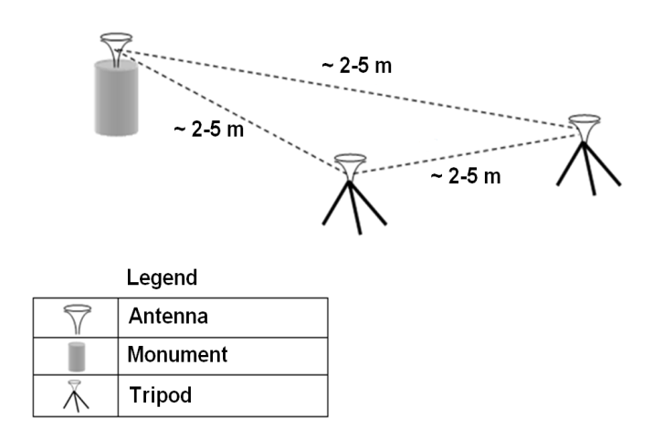
Figure 1: Test set up used at each test location.

Table 1: Data types collected during the field campaigns.
Field Survey | Data type | Duration | Total
Winter  (Dec. 2010) | Static NRTK | 8 hours | 288 hrs. (1 Hz, fixed)
Winter  (Dec. 2010) | Raw GPS | 8 hours | 288 hrs. (1 Hz, fixed)
Winter  (Dec. 2010) | TTFF | 5 trials | 135 trials
Summer  (July 2011) | NRTK | 6 hours | 80 hrs. (1 Hz, fixed)
Summer  (July 2011) | Raw GPS | 6 hours | 80 hrs. (1 Hz, fixed)
Summer  (July 2011) | Static solutions | 5 trials | 369 trials

Figure 2 shows the dense network of overlapping network RTK reference station from the three primary service providers in Southern Ontario. In mid-2010, there were over 70 stations covering a span of 900 km from Southwestern to Eastern Ontario, and this number has grown since then.

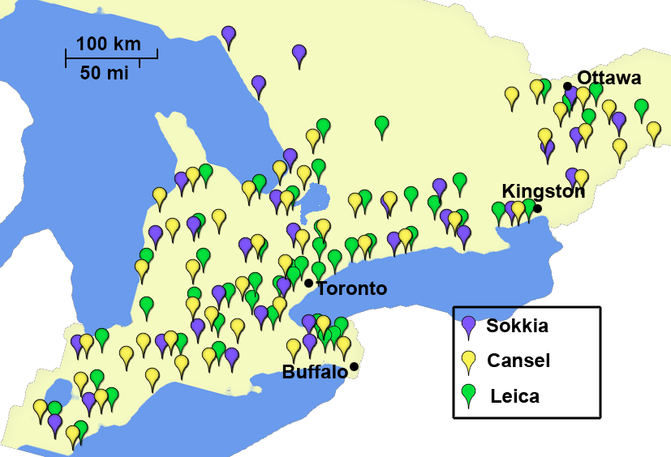
Figure 2: Network RTK reference stations in Southern Ontario in late 2010.

The locations of the nine sites visited for this study, where the testing configuration shown in Figure 1 was deployed, are shown in Figure 3: Peterborough, Belleville, Kingston, Ottawa, Kitchener, Windsor, London, St. Catharines and Barrie. Each location was chosen in a manner to cover all areas of interest in Southern and Eastern Ontario, at monuments with published coordinates, and nominally equidistant from each service provider’s local reference station.

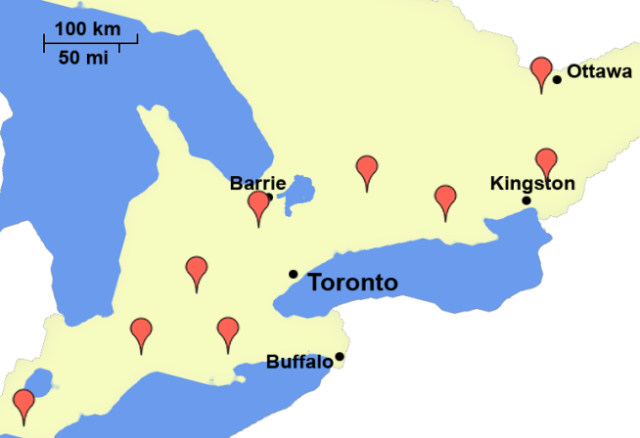
Figure 3: Test locations used in Southern Ontario.

Positioning Quality

In order to determine the stability of network RTK GPS user positioning, the ~8 hours of continuous static solutions collected for each service provider at each test site were analyzed. The following three figures provides examples of continuous user positioning over these long periods of time at different test locations using different services. Figure 4 illustrates a “good” solution set with solution error (defined as RTK position differenced from published or static GPS baseline-determined position) versus local time. Horizontally, a maximum error of ~1 cm is observed and the time series shows very little variation. Statistically, there are no significant positional biases in the solution. As expected, the up component shows approximately twice as much absolute error as each horizontal component. A very small standard deviation of 0.6 cm in the horizontal and 0.8 cm in the height is observed, indicating very stable user solutions over eight hours. And the averaged solution bias is insignificantly 0.1 cm and 0.2 cm in the north and east components, respectively, and 0.8 cm in the height.

Figure 4: Example of ‘good’ quality network RTK solution.

Figure 5 shows the existence of biases in this network RTK position solution. The time series in each component contains unexpected significant non-zero means. The solutions are very precise in the horizontal component, as illustrated in the relevant histograms and the standard deviation values. The standard deviations for north and east components are 0.9 and 0.6 cm, respectively. However, large overall biases of 1.5 and 3.1 cm in the north and east component, respectively, paint a picture of a precise but “not so accurate” solution. Also, a noticeable sinusoidal behaviour is observed, which cannot be directly explained, but more than likely arises from minor error mismodelling in the network RTK processing and / or measurement multipath at the user antenna.

Figure 5: Example of biased network RTK solution.

Figure 6 illustrates low frequency, high amplitude network RTK position solution variations. The solutions show a shorter period (~15 minute) oscillation through most of each time series, as compared to a ~20 minute period in Figure 5. As such a sinusoidal affect occurs in some data sets, the user should collect more than one set of observations, offset by minutes or hours, to determine a more accurate solution using network RTK. For example, in Figure 6, if hours 14 to 14.5 are considered, the solution varies from -5 cm in northing to +5 cm within a 15 minute window, meaning that if a user were to collect just a single position fix, or if the results were to be averaged using 5 minute windows, the solutions would differ significantly. Due to the real-time error estimation in the solution and the interpolation and filtering involved in network RTK, each epoch solution becomes part of a larger pattern that may affect the solution greatly. This result provides sufficient evidence to collect more than one set of observations for each survey, and to also separate the observation sampling by a few hours (possibly in different times of day) to avoid relying on observations that are not completely independent.

Figure 6: Example of sinusoidal behaviour in network RTK solution.

Positioning Precision

Figure 7 shows the horizontal network RTK precision (95%) for Company ‘A’ at each test site. The individual site precisions vary from 1.4 to 3.7 cm, with an average precision of 2.3 over all test sites. Results from all three service providers (not shown here) offer very similar precision levels (on average 2 - 3 cm) in almost all locations around Southern Ontario. These results suggest, that in terms of network RTK methods and network architecture, there is no significant difference between various methods of network RTK put forward by the service providers. Also, the results indicate horizontal precision (95%) below 5 cm in all locations.

Figure 7: Horizontal precision (95%) in winter campaign for Company ‘A’.

Figure 8 shows the company 'A' precision results (95%) for the winter campaign, with an average precision of 2.8 cm – slightly better than expected values for vertical precision of network RTK. The vertical precision, as expected, is higher than the horizontal precision shown earlier in this section; however, these are only a few millimetres larger. Typically, vertical precision and accuracy results are expected to be up to 2 times worse than the horizontal. The overall shape of the plot indicates that the vertical components perform consistently with the horizontal precision results.

Figure 8: Vertical precision (95%) in winter campaign for Company ‘A’.

Positioning Accuracy

Many hours of network RTK user position averages were compared to reference coordinates. Biases of 0.5 to 4 cm (horizontally) were observed, indicating possible reference station reference frame concerns, as the user biases can infer network RTK reference station coordinate biases. In Figure 9, biases and their directions at all test sites are shown for the Company ‘A’ results. For the most part, the biases are directed towards the southeast and the majority of the biases have magnitudes of 1 - 2.5 cm. This illustrates that Company ‘A’ network has a linear distortion of up to 3 cm horizontally. With closer alignment with a higher order network (e.g., CSRS network) these biases can be reduced, which is exactly what has since been done and will be discussed in the next section.

Figure 9: Horizontal biases in winter campaign for Company ‘A’.

Figure 10 shows the vertical mean errors across Southern Ontario for Company 'A'. It is difficult to deduce any particular pattern shown by these vertical translations; however, it can be seen that the eastern test sites show smaller mean errors than the western test sites, and that the direction of the biases vary with no particular pattern.

Figure 10: Vertical biases in winter campaign for Company ‘A’.

Position Averaging

The effect of moving average filtering on the horizontal maximum error of each solution set is investigated here to determine if static averaging of network RTK coordinates can improve positioning accuracy. Figure 11 shows the change in magnitude of maximum horizontal error with various window sizes for moving average filtering for Company ‘A’. In some cases, reductions of more than 5 cm in the horizontal maximum error can be observed. This result is of great importance to the average user, given their very limited period of observation. The results indicate that with up to 300 seconds of observations, the maximum error can be reduced significantly. For example, maximum horizontal position error at site ‘bel’ is shown to improve by of 5.8 cm with a 300 seconds time bin as opposed to a single 1 Hz position fix.

Figure 11: Moving average filtering vs. maximum error for Company ‘A’.

Long-Term Positioning Repeatability

Figure 12 compares the mean errors from the winter campaign with respect to the summer for Company ‘A’. The biases, though in some cases large, display a repeatable pattern. The magnitude of the biases over time may change from a few millimetres up to a centimetre. An anomaly can immediately be seen in the northing of ‘bel’ with a difference of ~2 cm. The systematic tendencies of these biases reinforce the assumption that the accuracy of solutions of each service provider is mainly influenced by network reference station misalignment, and the degree of integration of each network into the local high-accuracy datum. From these results, the degree of influence by immediate sources of error (geometry, visibility, multipath, etc.) can be categorized as random errors affecting the short-term quality of the solutions. And the larger sources of error, such as network distortions, can be categorized as systematic errors that affect the long-term repeatability of the solutions.

Figure 12: Long-term repeatability for Company ‘A’.

Solution Integrity

The solution integrity analysis consists of comparing the independently determined errors in the network RTK solution with the estimated coordinate uncertainty values that are provided to the user by service provider equipment to understand if a user can effectively determine the uncertainty of the determined network RTK coordinates. These coordinate quality (CQ) values vary from one service provider to another. Figure 13 shows the actual network RTK determined horizontal error (blue) in comparison with the 1σ, 2σ and 3σ values (red, yellow and green, respectively) determined from the network RTK estimation filter covariances for a period of two hours for Company ‘C’ at site ‘lon’ during the winter campaign. The network RTK horizontal solution error is predominantly within the boundaries of the one standard deviation values, indicating that, for this solution, the equipment uncertainty is overly optimistic. CQ values tend to follow the shape of the calculated solution errors, that is, they are usually within the 1σ level. However, the expanded portion of the plot shows the solution error being almost entirely outside the 1σ and for a small period time close to the 2σ boundaries, which still represents realistic uncertainty estimation from the equipment.

  - 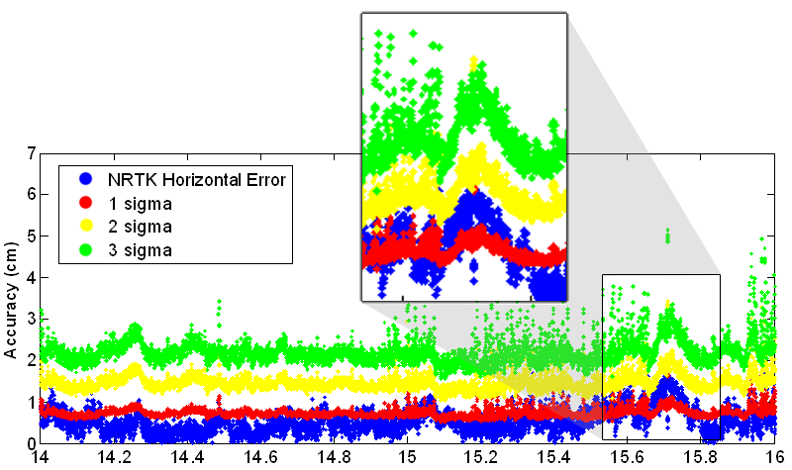
Figure 13: Company ‘C’ network RTK errors versus 1, 2 and 3 σ for 'lon'.

CERTIFICATION OF RTK NETWORK SERVICES

Given that a better understanding now exists of how well these specific network RTK services perform, a subsequent logical task for government agencies may be to develop procedures for ensuring that the services are operating as stated by the companies for the benefit of all stakeholders. Fundamentally, users of all categories would like to know how well the services perform (the previously discussed investigation), and do the services continually provide this performance (currently under investigation). And the service providers want to confirm that their users are correctly accessing the requisite reference frame. The current situation in Ontario leaves the onus on each service provider to develop and maintain their own systems of CORS infrastructure, network RTK software, user equipment and communications methodology, and the user to validate measured coordinates. The term “certification” in this context refers to a clearly defined and agreed upon joint approach between relevant government agencies and service providers to manage network RTK performance. Certification is not meant to mean review and acceptance of performance by some regulatory body – as network RTK requires a different mechanism due to its nature and complexity. This section considers the elements of such a certification, though detailed recommendations are not provided as the work is still on going.

Reference Station Integration

As can be seen by the earlier accuracy assessment, consistent user solution biases inferred reference station biases. These reference station biases in some networks can be traced to inconsistences in the determination of reference station coordinates with respect to the provincially mandated reference frame. What is required is the homogeneous integration of the network RTK reference station positions into the requisite reference frame, so as to allow users to access the reference frame. (This process with network RTK makes the reference stations akin to physical monumentation that user receivers are used to “survey from”.)

Determination of the coordinates of CORS sites spread over hundreds of kilometres at the few millimetre level requires specialized software and expertise – i.e., is no easy task. In a pilot experiment, the Geodetic Survey Division of Natural Resources Canada (NRCan) re-coordinated reference stations from commercial companies across Canada with respect to the national reference frame (Craymer and Piraszewski, 2012; Craymer, 2012) using 20 weeks of data from 2011. Aside from the complex task of GPS data processing is the time dependence of determined coordinates due to the moving North American plate. (While a surveyor or engineer is only interested in positions with respect to stable North America or relative positions, such movements must be accounted for as the GNSS satellites “observe” these motions from space.)

Methods and procedures are being devised at York University to replicate the NRCan static, relative GPS processing and adjustments, and also to determine the quality of Precise Point Positioning (PPP) processing as an alternative and / or supplement to reference station integration. Recommendations are being crafted to address the issues of how often to process reference station data for integration purposes and how to disseminate the resulting coordinates. Recommendations are also being prepared to describe options for who (e.g., an outside agency or the companies themselves) can perform reference station integration computations, for suggested monumentation, etc.

Reference Station Maintenance

Maintenance refers to the adding, removing or moving of stations from a network and updating station coordinates with respect to the desired datum. Static, relative and PPP processing are being investigated as options for these maintenance tasks. For example, while static, relative data processing produces the highest accuracy coordinates, PPP processing produces similar coordinates in a fraction of the time. So perhaps a few days of PPP solutions can be averaged to produce an initial, fairly accurate set of coordinates for a new reference station before a full network analysis is performed. Each service provider also has methods and software for maintenance, which may be similar, and could be integrated with or replace the suggested procedures.

A geodetic network analysis software tool is also being developed to carry out network analysis using well-established least-squares adjustment and statistical analysis methods. This tool will provide standard statistical testing to monitor existing network reference station coordinates and the effects of additional new reference stations to existing networks. Recommendations will be given as to best network adjustment practices when altering a network of reference stations.

User Solution Monitoring

Finally, the quality of the user solution should be understood. The performance evaluation described in the first portion of this paper was a significant undertaking, and is therefore not recommended as a procedure to continuously deploy to monitor the quality of user solutions. However elements of this evaluation can be used to systematically test the quality of a network RTK service at discrete locations and at discrete times. Some considered examples are: periodic user receiver occupations of Canadian Base Network (CBN) force-centred monuments; independent integrity monitoring CORS; and periodic analysis of client user solutions. These monitoring tools need to be used in combination with redundant measurements and independent check procedures by the user during a survey. User solution monitoring can be a potential activity of both the service providers and users.

CONCLUSIONS AND REMAINING WORK

The results of the evaluation study showed unified levels of short-term repeatability. In horizontal component of the solution precision, results indicate an overall precision of ~2.5 cm (95%) or better. However, one of the main issues of network RTK in Southern Ontario is that of solution biases in the horizontal components, which can be as large as 4 cm in isolated cases. NRCan static baseline processing of the reference stations appears to have corrected the problem.

Another issue is the fact that not all locations within these networks were assessed. With sufficient testing, “blind spots” can be found (as a few were found in this study), where the rover is well within the RTK network and yet no solution could be provided to the user. Comparing, in terms of accuracy and availability, network RTK in Southern Ontario with similar networks in such places as Great Britain and the state of Victoria in Australia, the averaged services provided in Ontario in 2010/2011 tended to slightly underperform. Though as stated above, this performance should now be slightly improved.

Finally, an issue that was encountered during the course of the network RTK evaluation was the lack of unified guidelines or procedures for the private networks to be integrated into Ontario’s official datum, NAD83 CSRS epoch 2007.0. This issue is being considered in the current “certification” study, which is investigating procedures to address reference station integration, reference station maintenance, and user solution monitoring.

ACKNOWLEDGEMENTS

The authors thank the Ministry of Transportation of Ontario and Natural Science and Engineering Research Council of Canada for financial support for this research, and Leica Geosystems Ltd., Cansel and Sokkia Corporation for loan of equipment and services.

REFERENCES
Al Marzooqi Y, H Fashir, T Babiker (2006) "Establishment of Dubai Virtual Reference System (DVSR) National GPS-RTK Network," FIG Working Week 2005, April 16-21, Cairo Egypt, 17 p

Bisnath S, J Wang, A Saeidi, G Seepersad (2012) "Utilization of Network RTK GPS in MTO Highway Surveys," Highway Infrastructure Innovation Funding Program (HIIFP) 2010, Ministry of Transportation - Ontario, St. Catharines, Canada

Craymer, M and M Piraszewski (2012) “NAD83 Integration of Commercial RTK Networks,” presentation at Canadian Geodetic Reference Systems Committee Meeting, 28-30 May, Geodetic Survey Division, Natural Resources Canada, Ottawa

Craymer, M (2012) Geodetic Survey Division, Natural Resources Canada. Personal communications

Delcev S, V Ogrizovic, V Vasilic, J Gucevic (2009) "Accuracy Testing of RTK Service of the Permanent Station Network in the Republic of Serbia," Surveyors Key Role in Accelerated Development, FIG Working Week 2009, Eilat, Israel, 3-8 May 2009, 15 p

Edwards S, P Clarke, S Goebell, N Penna (2008) “An Examination of Commercial Network RTK GPS Services in Great Britain,” Newcastle University, UK, 114 p

Jonsson B, G Hedling, P Wiklund (2002) "Some experiences of network-RTK in the SWEPOS™ network," Proceedings of the 14th General Meeting of the Nordic Geodetic Commission, NKG, 14th General Meeting, pp. 284-290

Rubinov E, G Hausler, P Collier (2011) “Evaluation of NRTK Heighting in Victoria: Impact of a Temporary Reference Station,” IGNSS Symposium 2011, 16 p

Saeidi A (2012) Evaluation of network RTK in Southern Ontario. MSc thesis, Graduate program in Earth and Space Science, York University, 178 p, http://www.yorku.ca/sbisnath

Saeidi A, S Bisnath, J Wang, G Seepersad (2011) "On the use of network RTK to replace static relative positioning for geodetic GPS surveys, ION GNSS 2011 Conference, 20-24 Sept. 2011, Portland Oregon, pp. 2310 - 2317

